**A PROJECT REPORT**

on

**“FARM MANAGEMENT SYSTEM”**

Submitted to

KIIT Deemed to be University

In Partial Fulfillment of the Requirement for the Award of

BACHELOR’S DEGREE IN

INFORMATION TECHNOLOGY

BY

Shubham Prabhat

Surya Narayan Gupta

Tushar Srivastava

Tushar Srivastava

Vaibhav Anand

1606145

1606151

1606155

1606156

1606158

UNDER THE GUIDANCE OF

Prof. Mamta Motwani



SCHOOL OF COMPUTER ENGINEERING

KALINGA INSTITUTE OF INDUSTRIAL TECHNOLOGY

BHUBANESWAR, ODISHA - 751024

July 2019

KIIT Deemed to be University

School of Computer Engineering

Bhubaneswar, ODISHA 751024



CERTIFICATE

This is certify that the project entitled

**“FARM MANAGEMENT SYSTEM”**

submitted by

Shubham Prabhat

Surya Narayan Gupta

Tushar Srivastava

Tushar Srivastava

Vaibhav Anand

1606145

1606151

1606155

1606156

1606158

is a record of bonafide work carried out by them, in the partial fulfilment of the

requirement for the award of Degree of Bachelor of Engineering in Information Technology at KIIT Deemed to be university, Bhubaneswar. This work is done during year 2018-2019, under our guidance.

Date: / /

(Prof. Mamta Motwani)

Project Guide

**ACKNOWLEDGEMENT**

*We take this opportunity to express our gratitude to the people who have been instrumental in the successful completion of this project we take immense pleasure in thanking and warmly acknowledging the continuous encouragement, invaluable supervision, timely suggestions and Inspired guidance offered by our project mentor Mrs. Mamta Motwani, Associate Professor, School of Computer Engineering, KIIT University, in bringing this report to a successful completion we are grateful to Dr. S. Mishra, Dean of the School of Computer Engineering for permitting us to make use of the facilities available in the department to carry out the project successfully we also express our sincere thanks to all our friends who have patiently extended all sorts of help for accomplishing this undertaking. Also, we would like to express our heartfelt thanks to each of our beloved parents for their blessings, for their help and wishes for the successful completion of this project.Finally we extend our gratefulness to one and all that are directly or indirectly involved in the successful completion of this project work.*

Shubham Prabhat (1606145)

Surya Narayan Gupta (1606151)

Tushar Srivastava (1606155)

Tushar Srivastava (1606156)

Vaibhav Anand (1606158)

**ABSTRACT**

The purpose of Farm Management System is to automate the existing manual system by the help of computerized equipments and full-fledged computer software, fulfilling their requirements, so that their valuable data/information can be stored for a longer penod with easy accessing and manipulation of the same. The required software and hardware are easily available and easy to work with.

Farm Management System, as described above, can lead to error free, secure reliable and fast management system. It can assist the user to concentrate on their other activities rather to concentrate on the record keeping. Thus it will help organization in better utilization of resources. The organization can maintain computerized records

without redundant entries. That means that one need not be distracted by information that is not relevant, while being able to reach the information.

The aim is to automate its existing manual system by the help of computerized equipments and full-fledged computer software, fulfilling their requirements so that their valuable data information can be stored for a longer period with easy accessing and manipulation of the same. Basically the project describes how to manage for good performance and better services for the clients.

Contents

|  |  |  |  |
| --- | --- | --- | --- |
| 1 | Introduction . . . . . . . . . . . . . . . . . . . . . . . . . . . . . . . . . . . . . . . . . . . | | 1 |
|  | 1.1 | Objective . . . . . . . . . . . . . . . . . . . . . . . . . . . . . . . . . . . . . . . . . | 2 |
|  | 1.2 | Scope . . . . . . . . . . . . . . . . . . . . . . . . . . . . . . . . . . . . . . . . . . . . | 2 |
| 2 | Literature Survey . . . . . . . . . . . . . . . . . . . . . . . . . . . . . . . . . . . . . . . | | 3 |
|  | 2.1 | Why Farm Mangement System..?. . . . . . . . . . . . . . . . . . . . . | 3 |
|  | 2.2 | Internet Of Things . . . . . . . . . . . . . . . . . . . . . . . . . . . . . . . . . | 3 |
|  |  | 2.2.1 Arduino UNO . . . . . . . . . . . . . . . . . . . . . . . . . . . . . . . . | 4 |
|  |  | 2.2.2 NodeMCU . . . . . . . . . . . . . . . . . . . . . . . . . . . . . . . . . . . | 4 |
|  |  | 2.2.3 DHT11 . . . . . . . . . . . . . . . . . . . . . . . . . . . . . . . . . . . . . . . | 5 |
|  |  | 2.2.4 Ultrasonic Sensor . . . . . . . . . . . . . . . . . . . . . . . . . . . . . | 5 |
|  |  | 2.2.5 Soil Moisture Sensor . . . . . . . . . . . . . . . . . . . . . . . . . . . | 5 |
|  |  | 2.2.6 Relay Switch . . . . . . . . . . . . . . . . . . . . . . . . . . . . . . . . . | 6 |
|  |  | 2.2.7 AC Motor . . . . . . . . . . . . . . . . . . . . . . . . . . . . . . . . . . . . | 6 |
| 3 | Software Requirements Specification . . . . . . . . . . . . . . . . . . . . . . | | 7 |
|  | 3.1 | System Requirements . . . . . . . . . . . . . . . . . . . . . . . . . . . . . . | 7 |
|  | 3.2 | Functional Requirements . . . . . . . . . . . . . . . . . . . . . . . . . . . . | 7 |
|  | 3.3 | Non Functional Requirement . . . . . . . . . . . . . . . . . . . . . . . . | 8 |
|  |  | 3.3.1 Performance Requirements . . . . . . . . . . . . . . . . . . . . . | 8 |
|  |  | 3.3.2 Safety Requirements . . . . . . . . . . . . . . . . . . . . . . . . . . . | 8 |
|  |  | 3.3.3 Software Quality Attributes . . . . . . . . . . . . . . . . . . . . . | 8 |
|  | 3.4 | Design . . . . . . . . . . . . . . . . . . . . . . . . . . . . . . . . . . . . . . . . . . . | 9 |
|  |  | 3.4.1 UML Design . . . . . . . . . . . . . . . . . . . . . . . . . . . . . . . . . . | 9 |
|  |  | 3.4.1.1 Sequence Diagram . . . . . . . . . . . . . . . . . . . . . . . | 9 |
|  |  | 3.4.1.2 Activity Diagram . . . . . . . . . . . . . . . . . . . . . . . . . | 10 |
|  |  | 3.4.2 Circuit Design . . . . . . . . . . . . . . . . . . . . . . . . . . . . . . . . . | 13 |
| 4 | Design And Implementation. . . . . . . . . . . . . . . . . . . . . . . . . . . . . . | | 14 |
|  | 4.1 | Collecting Raw Data through Sensor . . . . . . . . . . . . . . . . . . . | 14 |
|  | 4.2 | Sending Data to Cloud. . . . . . . . . . . . . . . . . . . . . . . . . . . . . . . | 16 |
| 5 | System Testing . . . . . . . . . . . . . . . . . . . . . . . . . . . . . . . . . . . . . . . . . | | 21 |
| 6 | Conclusion and Future Scope . . . . . . . . . . . . . . . . . . . . . . . . . . . . . | | 22 |
|  | 6.1 | Conclusion . . . . . . . . . . . . . . . . . . . . . . . . . . . . . . . . . . . . . . | 22 |

|  |  |
| --- | --- |
| 6.2 Future Scope . . . . . . . . . . . . . . . . . . . . . . . . . . . . . . . . . . . . . . | 23 |
| References . . . . . . . . . . . . . . . . . . . . . . . . . . . . . . . . . . . . . . . . . . . . . . . | 24 |

List of Figures

|  |  |  |
| --- | --- | --- |
| 3.1 | Sequence Diagram For Ultrasonic sensor. . . . . . . . . . . . . . . . . . . . . | 9 |
| 3.2 | Sequence Diagram For Temprature And Humidity Sensor. . . . . . . . | 10 |
| 3.3 | Activity Diagram For Soil Moisture Sensor. . . . . . . . . . . . . . . . . . . . . | 12 |
| 3.4 | Circuit Diagram For Complete Project. . . . . . . . . . . . . . . . . . . . . . . . . | 13 |
| 3.5 | Circuit Diagram For Soil Moisture Sensor. . . . . . . . . . . . . . . . . . . . . . | 13 |
| 4.1 | Code for initializing Pins and variables. . . . . . . . . . . . . . . . . . . . . . . . | 14 |
| 4.2 | Ultrasonic Sensor and Moisture Sensor. . . . . . . . . . . . . . . . . . . . . . . | 15 |
| 4.3 | DHT11 sensor and Relay. . . . . . . . . . . . . . . . . . . . . . . . . . . . . . . . . . . . | 16 |
| 4.4 | Transfer Data through JSON Buffer. . . . . . . . . . . . . . . . . . . . . . . . . . . | 16 |
| 4.5 | Includng libraries and required variables . . . . . . . . . . . . . . . . . . . . . . | 17 |
| 4.6 | Initializing all the ports . . . . . . . . . . . . . . . . . . . . . . . . . . . . . . . . . . . . | 18 |
| 4.7 | Fetching data through JSON Buffer. . . . . . . . . . . . . . . . . . . . . . . . . . . | 18 |
| 4.8 | Sending Data to ThinksBoard Cloud. . . . . . . . . . . . . . . . . . . . . . . . . . | 19 |
| 4.9 | Initializing the WiFi connection. . . . . . . . . . . . . . . . . . . . . . . . . . . . . . | 19 |
| 4.10 | Reconnect to WiFi. . . . . . . . . . . . . . . . . . . . . . . . . . . . . . . . . . . . . . . . | 20 |
| 4.11 | Console Output for JSON Connection. . . . . . . . . . . . . . . . . . . . . . . . . | 20 |

**Chapter-1**

**INTRODUCTION**

The “*Farm Management System”* has been developed to override the problems prevailing in the practicing manual system. This software is supported to eliminate and in some cases reduce the hardships faced by this existing system. Moreover this system is designed for the particular need of the company to carry out operations in a Smooth and effective manner.It is an IoT based project pertaining to smart irrigation system. The project deals in tracking the location of trees/plantation areas, locating them on Google Map,creating a database with geospatial references and providing their present condition like soil water level, air humidity and temperature in the surrounding which will save plants from getting undernourished and eventual death.

The application is reduced as much as possible to avoid errors while entering the data.It also provides error message while entering invalid data. No formal knowledge is needed for the user to use this system. Thus by this all it proves it is user-friendly Farm

Management System. It can assist the user to concentrate on their other activities rather to concentrate on the record keeping.

Every organization, whether big or small, has challenges to overcome and managing the information of Crops, Farm, and Equipments. Every Farm Management System has different Farm needs, therefore we design exclusive employee management systems that are adapted to your managerial requirements.This is designed to assist in strategic planning, and will help you ensure that your organization is equipped with the right level of information and details for your future goals. Also, for those busy executive who are always on the go, our systems come with remote access features, which will allow you to manage your workforce anytime, at all times. These systems will ultimately allow you to better manage resources.

* 1. Objective :

The main objective of the Project on Farm Management System is to manage the details of Farm and Crops. It manages all the information about Farm, Cost Range and Farm. The project is totally built at administrative end and thus only the administrator is guaranteed the access. The purpose of the project is to build an application program to reduce the manual work for managing the Farm, Crops, Cost Range, Crops. It tracks all the details about the Crops.

* 1. Scope :

It may help collecting perfect management in details. In a very short time, the collection will be obvious, simple and sensible. It will help a person to know the management of passed year perfectly and vividly. It also helps in current all works relative to Farm Management System. It will be also reduced the cost of collecting the management & collection procedure will go on smoothly.

* It satisfies the user requirement.
* It is easy to understand by the user and operator.
* The system generates types of information that can be used for various purposes.

**Chapter 2**

Literature Survey

2.1 WHY FARM MANAGEMENT SYSTEM..?

Farming is the most important occupation of India. 70% of the population is engaged in farming.. In the process, millions of crops are planted every year.However, many saplings planted with so much enthusiasm and fanfare die an untimely death due to lack of care and support. It needs a little attention and protection against grazing, dry condition, and hazards of other biotic and abiotic factors. Crops raised by the nurseryman with lot of care and skill in picking the best quality seed, its proper treatment for better germination, adequate mixture of soil and manure, watering and weeding for six months or even prolonged period for two to three years in case of tall saplings, conditioning of plants to withstand adversity of nature etc. All these labour and time is wasted when the seedlings die due to lack of care.

Planting is just a beginning. It has to be taken care and nurtured as a kid. In this age of GIS, to watch the crops we plant, we have to locate it in Google map and create a database with Spatial reference. Thereby we can identify our plant and know about its

present condition. This data has to be accessible through a simple Smartphone application by all citizens. A suitable App or other solutions need to be developed to Geo-Tag the trees and have a database of such plantations with Geospatial reference.

2.2 Internet Of Things:

The Internet of things is the extension of Internet connectivity into physical devices and everyday objects. Embedded with electronics, Internet connectivity, and other forms of hardware, these devices can communicate and interact with others over the Internet, and they can be remotely monitored and controlled.

**2.2.1 Arduino Uno**

The Arduino Uno is an [open-source](https://en.wikipedia.org/wiki/Open-source) [microcontroller](https://en.wikipedia.org/wiki/Microcontroller_board) board based on the [Microchip](https://en.wikipedia.org/wiki/Microchip_Technology) [ATmega328P](https://en.wikipedia.org/wiki/ATmega328P) microcontroller and developedby Arduino.cc.The board is equipped with sets of digital and analog input/output (I/O) pins that may be interfaced to various expansion boards (shields) and other circuits. The board has 14 Digital pins, 6 Analog pins, and programmable with the Arduino IDE (Integrated Development Environment) via a type B USB cable. It can be powered by the USB cable or by an external 9-volt battery, though it accepts voltages between 7 and 20 volts.

**2.2.2 NodeMCU**

NodeMCU is an open source [IoT](https://en.wikipedia.org/wiki/Internet_of_Things) platform. It includes [firmware](https://en.wikipedia.org/wiki/Firmware) which runs on the [ESP8266](https://en.wikipedia.org/wiki/ESP8266) [Wi-Fi](https://en.wikipedia.org/wiki/Wi-Fi) [SoC](https://en.wikipedia.org/wiki/System_on_a_chip) from Espressif Systems, and hardware which is based on the ESP-12 module. The term "NodeMCU" by default refers to the firmware rather than the development kits. The firmware uses the [Lua](https://en.wikipedia.org/wiki/Lua_(programming_language)) scripting language. It is based on the eLua project, and built on the Espressif Non-OS SDK for ESP8266.

**2.2.3 DHT11**

DHT11 Temperature & Humidity Sensor features a temperature & humidity sensor complex with a calibrated digital signal output.By using the exclusive digital-signal-acquisition technique and temperature & humidity sensing technology, it ensures high reliability and excellent long-term stability. This sensor includes a resistive-type humidity measurement component and an NTC temperature measurement component, and connects to a high performance 8-bit microcontroller, offering excellent quality, fast response, anti-interference ability and cost-effectiveness.

**2.2.4 Ultrasonic Sensor**

An ultrasonic sensor is an instrument that measures the distance to an object using ultrasonic sound waves. An ultrasonic sensor uses a transducer to send and receive ultrasonic pulses that relay back information about an object’s proximity. High-frequency sound waves reflect from boundaries to produce distinct echo patterns.

**2.2.5 Soil Moisture Sensor**

Soil moisture sensors measure the volumetric [water content](https://en.wikipedia.org/wiki/Water_content) in [soil.](https://en.wikipedia.org/wiki/Soil) Since the direct [gravimetric measurement](https://en.wikipedia.org/wiki/Gravimetric_analysis) of free soil moisture requires removing, drying, and weighting of a sample, soil moisture sensors measure the volumetric water content indirectly by using some other property of the soil, such as electrical resistance, dielectric constant, or interaction with [neutrons,](https://en.wikipedia.org/wiki/Neutron) as a proxy for the moisture content.

**2.2.6 Relay**

Relays are electromechanical devices that use an electromagnet to operate a pair of movable contacts from an open position to a closed position.The advantage of relays is that it takes a relatively small amount of power to operate the relay coil, but the relay itself can be used to control motors, heaters, lamps or AC circuits which themselves can draw a lot more electrical power.

**2.2.7 AC Motor**

An AC motor is an electric engine driven by an exchanging flow (AC). The AC engine usually comprises of two essential parts, an outside stator having loops provided with exchanging current to deliver a turning attractive field, and an inside rotor connected to the yield shaft creating a second pivoting attractive field

**Chapter 3**

**Software Requirements Specification**

**Software Requirements Specifications (SRS)** is a description of a software system to be developed, laying out functional and non functional requirements, and may include a set of use cases that describe interactions the users will have with the software.

3.1 System Requirements:

To run this project, we will need different types of software, sensors, hardware and tools, such as:

* Arduino IDE(To program the arduino)
* Blynk App(To display the output on android device)
* ThinksBoard(To display the output on desktop)
* Arduino Uno
* Ultrasonic Sensor
* Temperature and Humidity sensor (DHT11)
* Soil Moisture Sensor
* NodeMCU
* AC Motor
* Relays

3.2 Functional Requirements:

* Smart Agriculture System
* Automatic Irrigation System
* Simple system solves complex task
* User friendly interface
* Cost effective for large scale implementation
* Low power consumption and long self life
* Allows monitoring of all registered plantation areas from anywhere anytime
* Water conservation by irrigating only when required
* Automated system for long lasting solution
* Cellular structure and frequency planning to give better coverage
* Room to improvise to higher performance
* Precision agriculture using IoT

**3.3 Non Functional Requirements:**

**3.3.1 Performance Requirements:**

Performance of the system depends on the response time, speed and accuracy of the data submission. The response time of the system is directly dependant on the sensors used. The frequency of the data sent determines the speed of data and also correlates to the accuracy of the data received. In the prototype, the data received is raw and without any preprocessing.

**3.3.2 Safety Requirements:**

* The product should be free of any electrical leakage.
* The product should be waterproof to avoid any damage to the sensors and micro controllers.
* Null values should be checked for all the sensors prior to the deployment.

**3.3.3 Software Quality Attributes:**

The system should have a simple and user friendly graphical interface so that the demographic user can understand and take the benefits of all the features properly. All user should be informed of any unforeseen event that might affect the crops.

**3.4 Design:**

**3.4.1 UML Design:**

**3.4.1.1 Sequence diagram:**

A sequence diagram shows how processes operate with one another and in what order. A sequence diagram shows the interactions arranged in time sequences. It depicts the object and the classes involved in the scenario and the sequence of the message exchanged between the objects needed to carry out the functionality if the scenario. 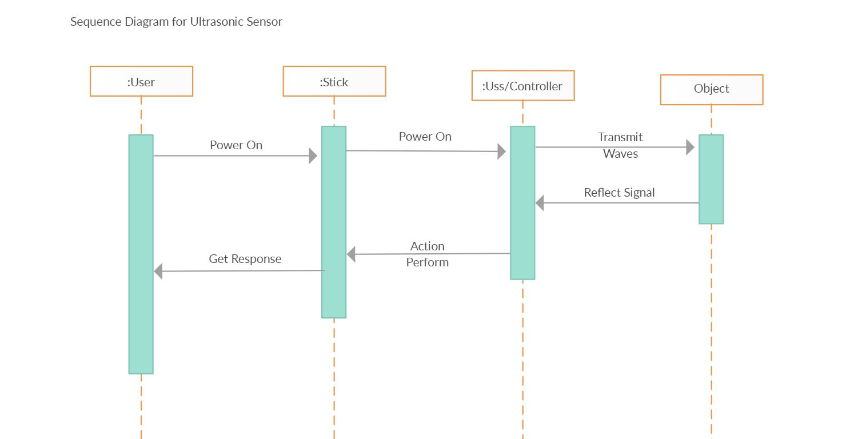

**Fig. 3.1 Sequence Diagram for Ultrasonic Sensor**

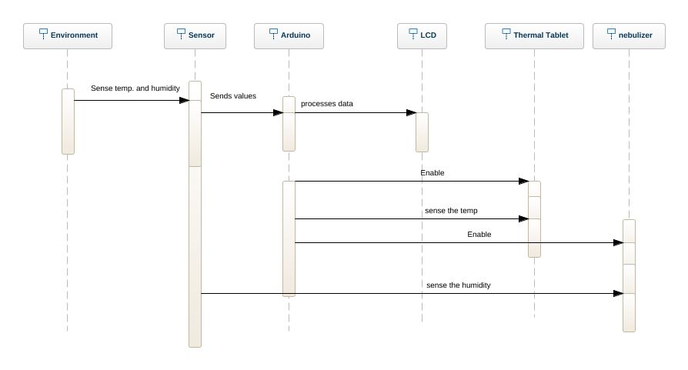

**Fig. 3.2 Sequence Diagram for Temperature and Humidity Sensor**

3.4.1.2 Activity diagram:

Activity diagrams are graphical representation of workflows of stepwise activities and actions with support of choice, iteration and concurrency. Activity diagrams show the workflow from a start point to the finish point detailing the many decision paths that exist in the progression of events contained in the activity. They may b used to detail the situations where parallel processing may occur in the execution of some activities. Activity Diagrams are useful for business modelling where the are used for detailing the processes involved in business activities.

Following are some of the elements that constitute an activity diagram.

***Actions***

An action represents a single step in an activity. Actions are denoted by small round cornered boxes.

***Control Flow***

A control flow shows the flow of control from one action to another. Its notation is a line with an arrow.

***Initial Node***

Initial or start node is depicted by a large black spot.

***Final Node***

There are two types of final node: Activity final node and Flow final node. The activity final node is depicted by a circle with a large dot inside.

***Decision and merge node***

The decision node and merge node have the same notation, i.e. A diamond shaped box. They can both be named. The control flows coming away from the decision node will have a guard condition which will allow the control to flow only if the condition is met.

***Fork and Join node***

Forks and join nodes have the same notation: either a horizontal or vertical bar. They indicate the start and end of the concurrent threads of control.

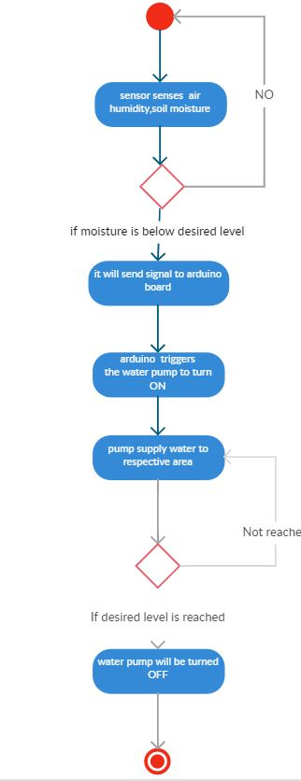

**Fig. 3.3 Activity Diagram for Soil Moisture Sensor**

**3.4.1 Circuit Design:**

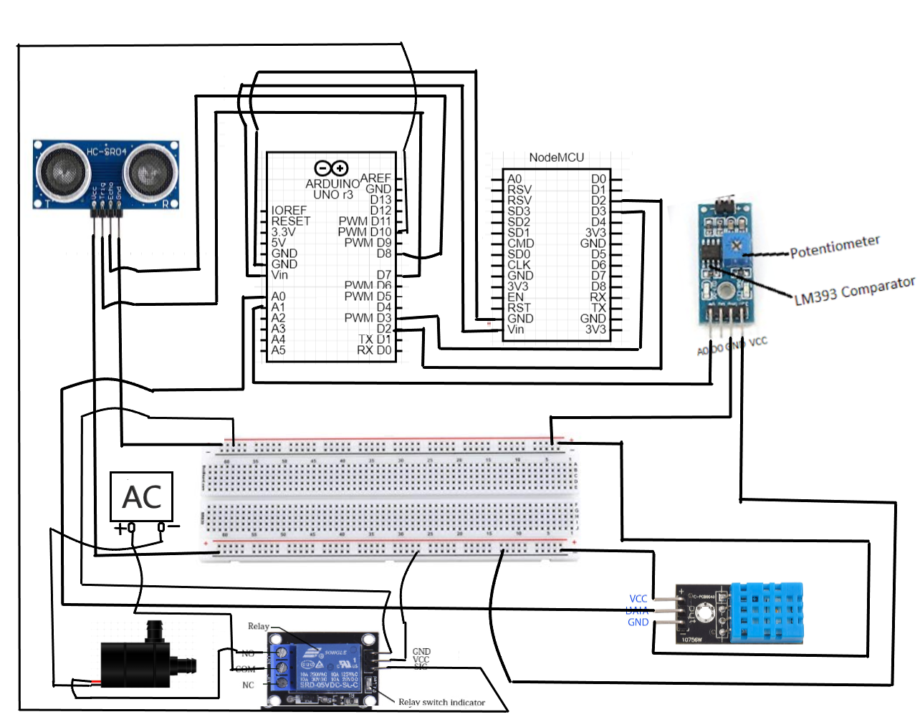

**Fig. 3.4 Circuit Diagram for Complete Project**

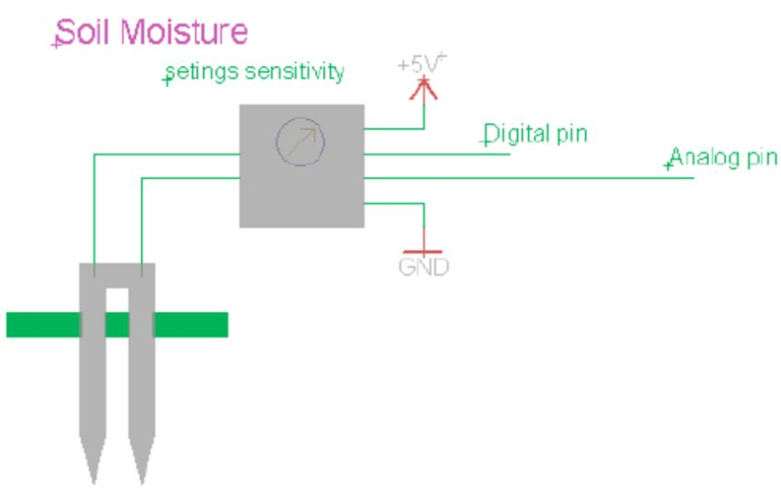

**Fig. 3.5 Circuit Diagram for Soil Moisture**

**Chapter 4**

**Design and Implementation**

**4.1 Collecting Raw Data Through Sensors**

* All the variables and pins for the Arduino are initialized in Fig. 4.1.

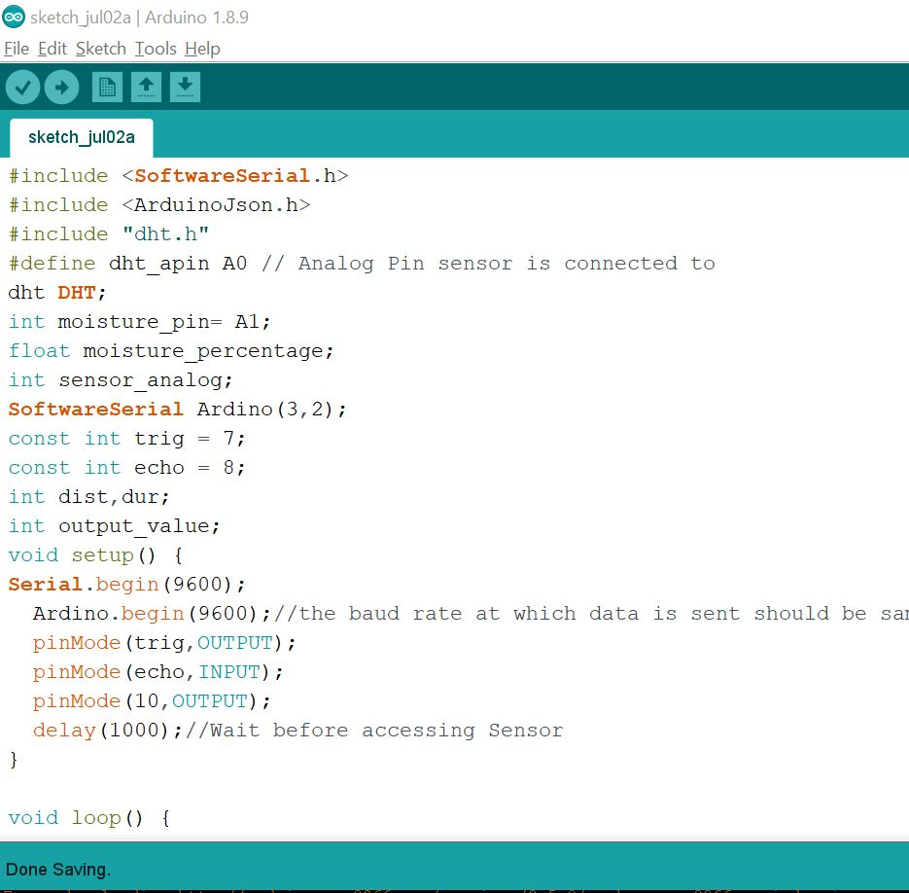

**Fig 4.1 Code for the initialization of pins and variables**

* In Fig. 4.2, the loop method has started.
* First we extract the data for the ultrasonic sensor, here we have initialized the trigger with LOW to avoid any prior noise.
* The ultrasonic sensor is triggered for a shot amount of time and the the reflected waves are received by the ECHO pin. With the help of the time difference we can calculate the distance between the surface and the sensor.
* Secondly, we calculate the soil moisture level through soil moisture sensor.

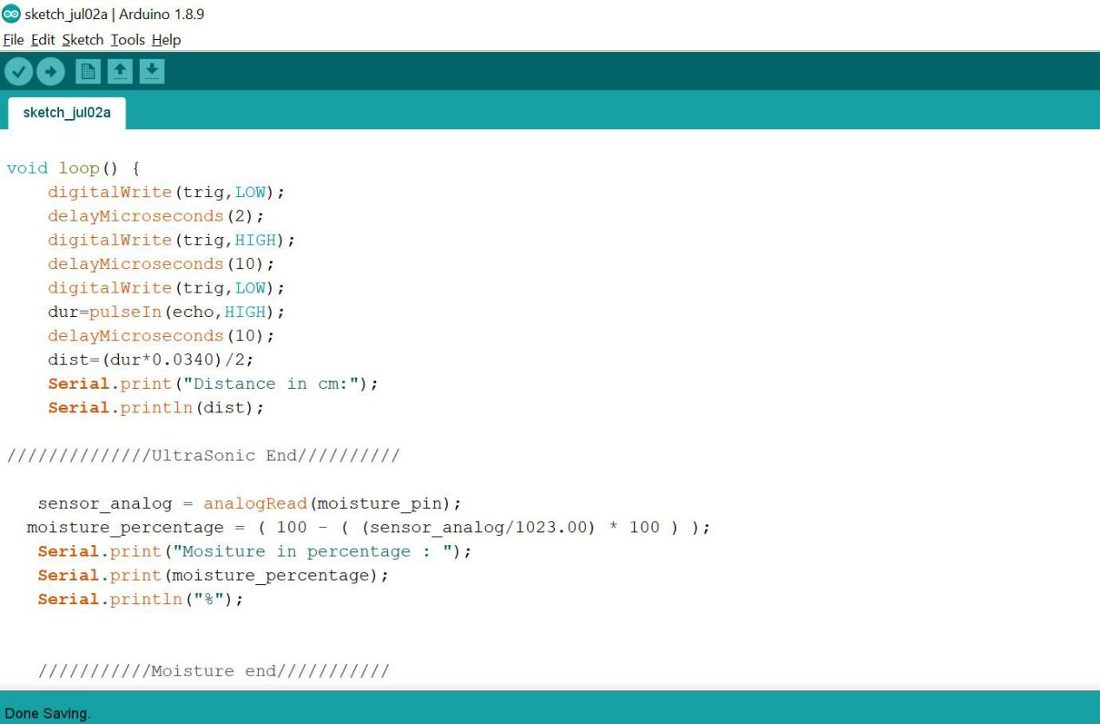

**Fig. 4.2 Ultrasonic sensor and Moisture sensor**

* In Fig 4.3 the data for temperature and humidity is taken through DHT11 Sensor and the condition for data transfer through relay is set.

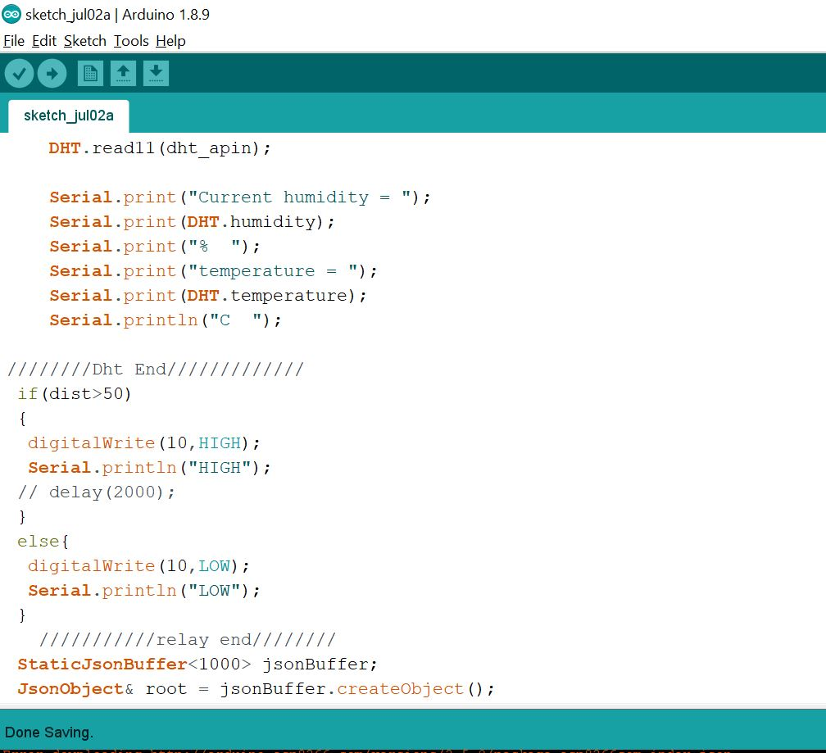

**Fig. 4.3 DHT11 sensor and Relay**

* In Fig. 4.4 we send the data through JSON Buffer.

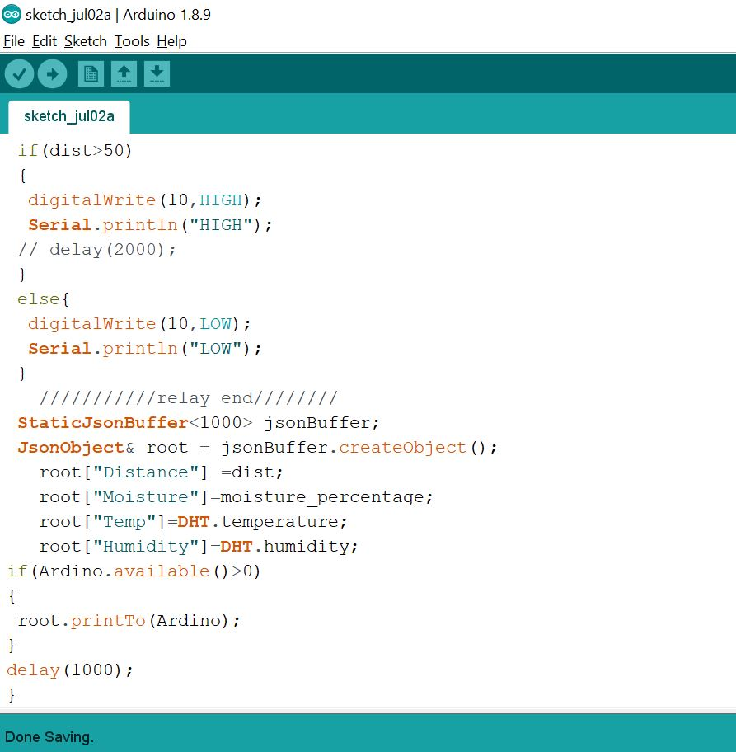

**Fig. 4.4 Transfer Data through JSON Buffer**

**4.2 Sending Data to cloud**

* In Fig. 4.5 all the necessary Libraries are included and the basic variables for Id and password for the connection to Wi-Fi is defined.

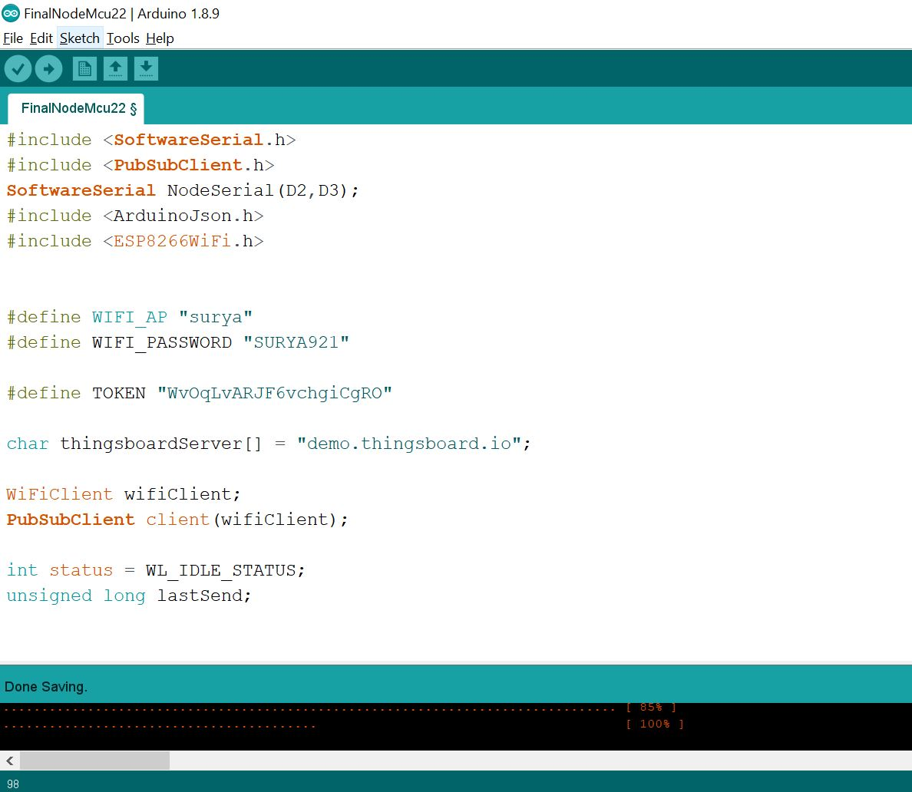

**Fig. 4.5 Including Libraries and Defining required Variables**

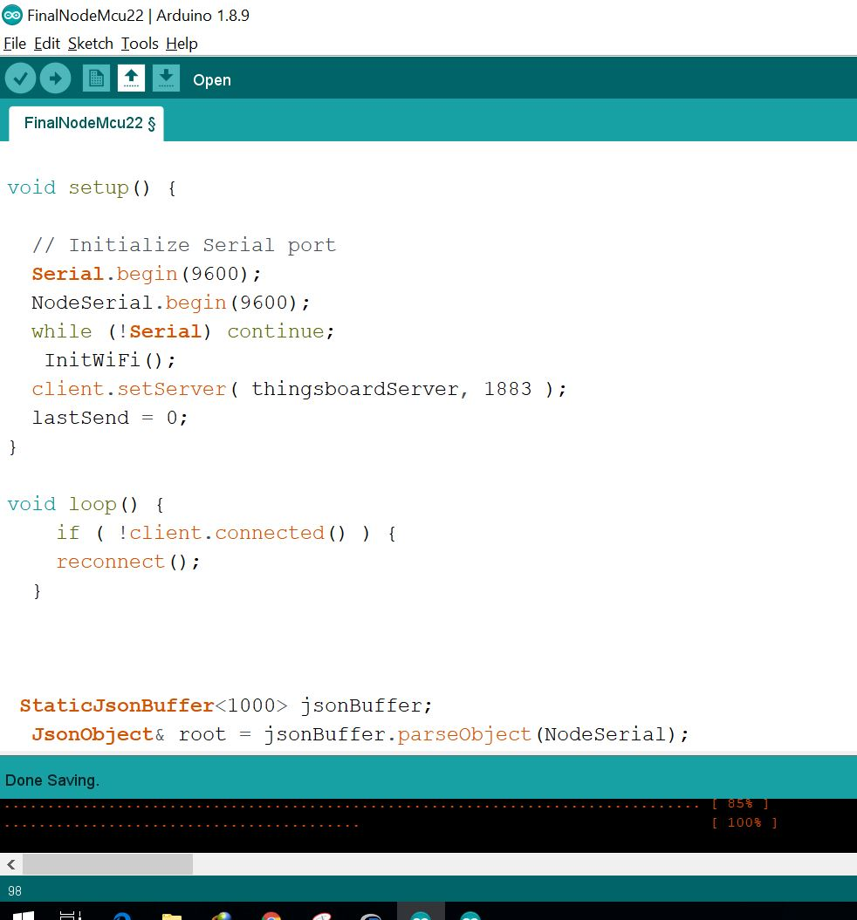

**Fig. 4.6 Initializing all the ports**

* In Fig 4.7, the data is received from Arduino UNO through JSON Buffer.

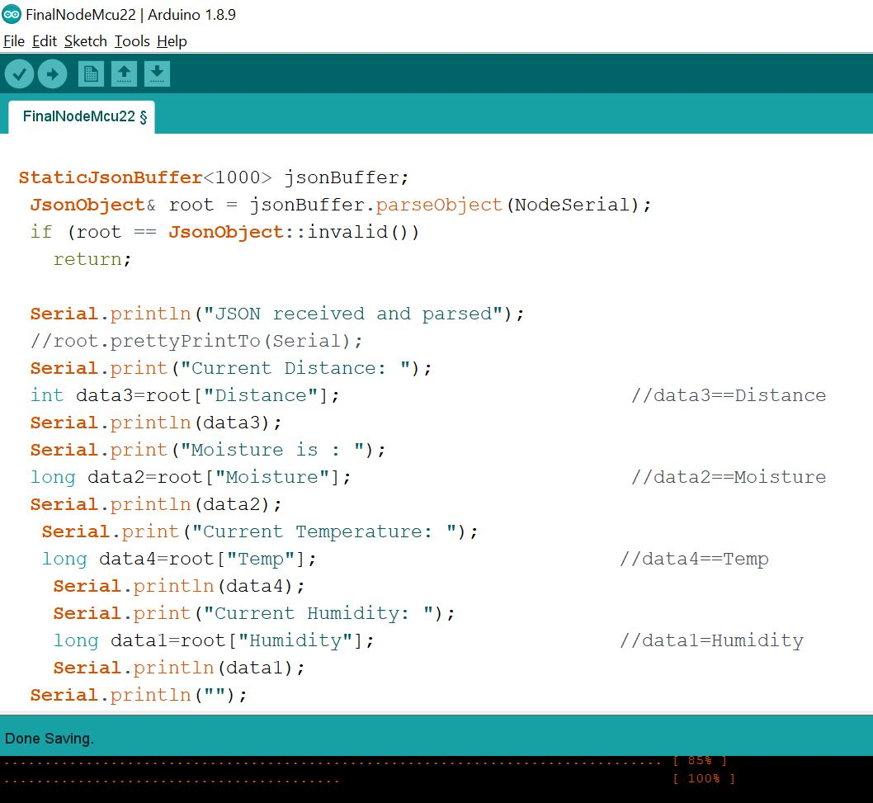

**Fig. 4.7 Fetching data through JSON Buffer**

* In Fig 4.8, the data is sent to the cloud.

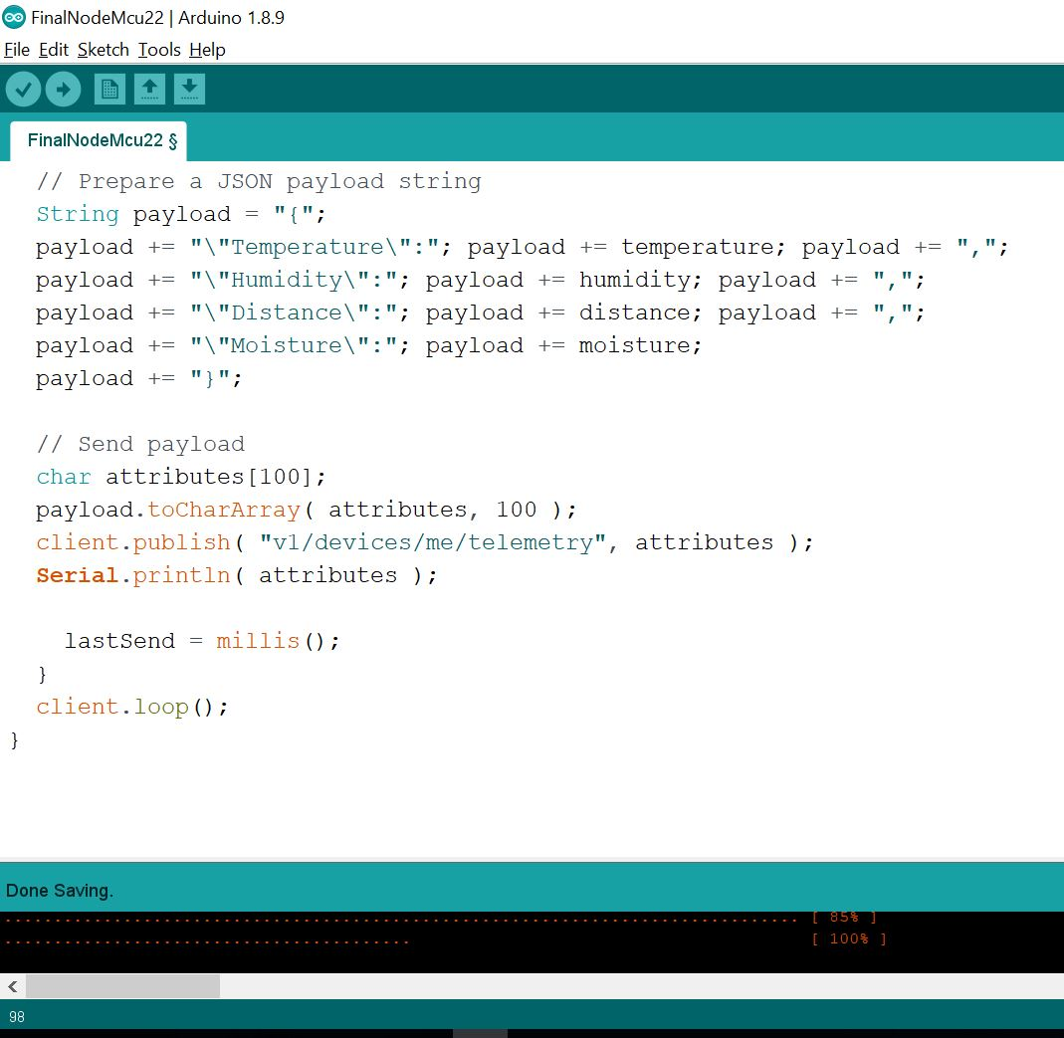

**Fig. 4.8 Sending data to Thinks Board cloud**

* In Fig 4.9, the connection to Wi-Fi is initialized.

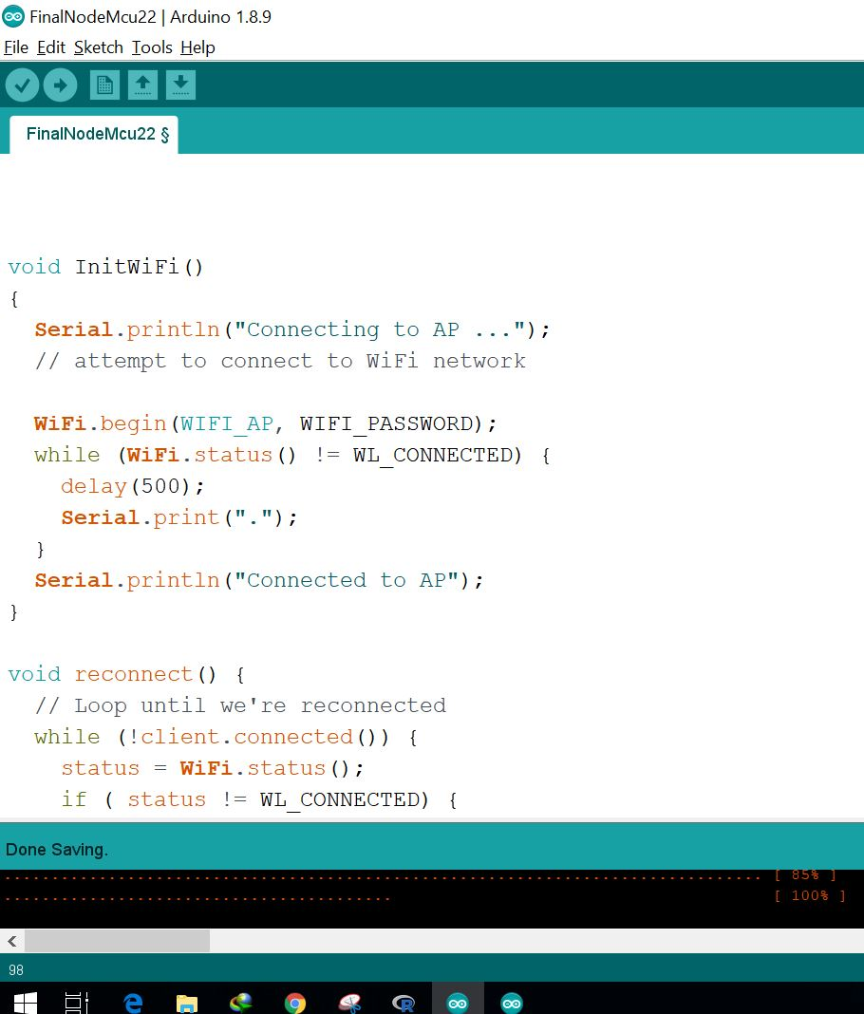

**Fig. 4.9 Initializing The WI-FI Connection**

* In Fig. 4.10, the re-connection is established. If the connection fails, this method enables us to reconnect to the WiFi network.

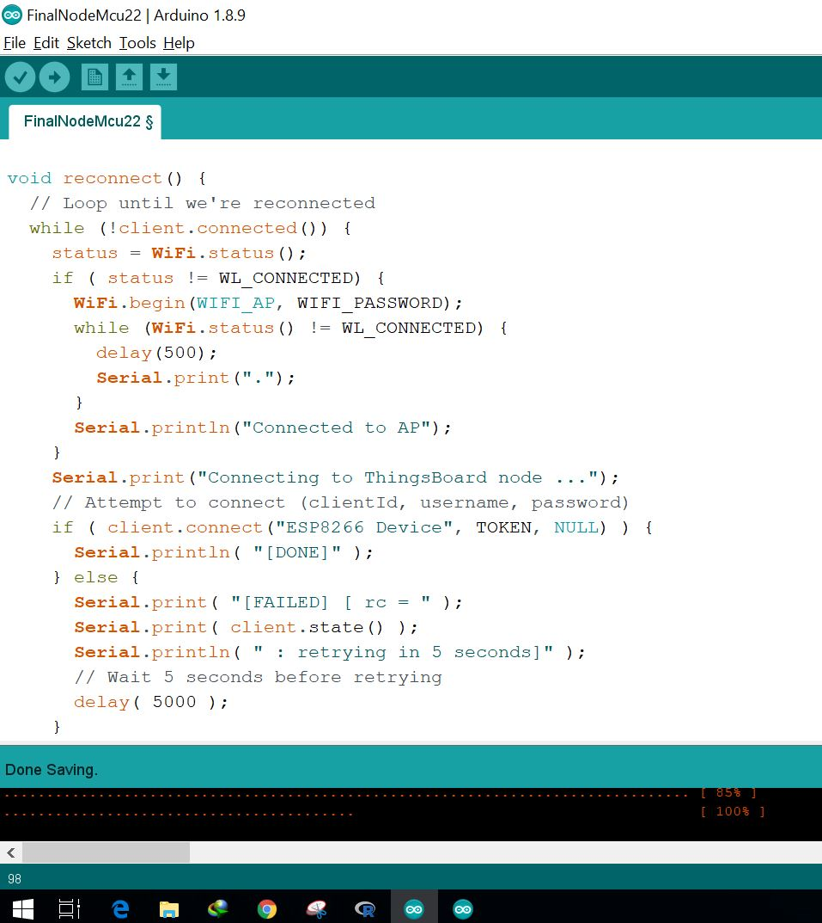

**Fig. 4.10 Reconnect to WiFi**

* Console output for receiving data from Arduino UNO through JSON Buffer and sending it to the ThinksBoard cloud is shown in Fig. 4.11.

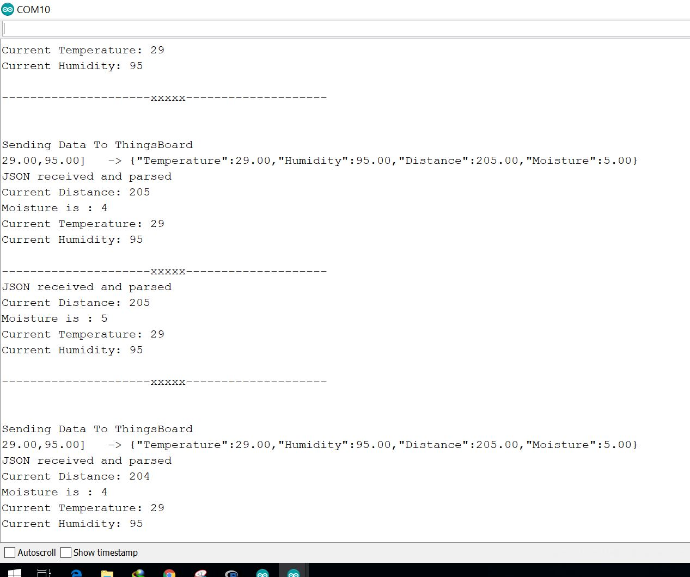

**Fig. 4.11 Console output for JSON Connection**

**Chapter 5**

**System Testing**

|  |  |  |  |  |
| --- | --- | --- | --- | --- |
| **D** | **Test Case Title** | **Test Condition** | **System Behavior** | **Expected Result** |
| T01 | Humidity | Measuring the atmosphere’s humidity | OK | Humidity:95% |
| T02 | Temperature | Measuring the atmosphere’s temperature | OK | Temperature:31 C |
| T03 | Moisture | Measuring the soil moisture | OK | Moisture: 73% |
| T04T | Distance | Measuring the Distance, It Should be less than 50 cm | OK | Distance: 49cm |
| T05 | Distance | Measuring the Distance, It Should be greater than 50 cm | OK | Distance: 60cm |
| T06 | Motor Status | Measuring the Distance, if greater than 50 cm, Motor to be started | OK | Motor Started |
| T07 | Motor Status | Measuring the Distance, if less than 50 cm, Motor to be stopped | OK | Motor Stopped |

**6.1 Test Cases and Test Results**

**Chapter 6**

Conclusion and Future Scope

10.1 Conclusion

This Farm Management System helps you plan, monitor and analyze all activities on your farm easily.This work is part of a project that intends to support small farmers in poor regions. Specifically, it intends to aid government agencies related to the agribusiness to support the development of these economically endangered communities by providing the proper guidance to design and manage their production system at farm scale.

The goal is to increase production using resources available on the farm or supplied by the environment, eventually also provided by the government. The expected result is to achieve sustainable development outcomes that can benefit the entire local population, particularly the poorest, while limiting ecological impacts.

10.2 Future Scope

In the Internet era, where information plays a key role in people’s lives, agriculture is rapidly becoming a very data

intensive industry where farmers need to collect and evaluate a huge amount of information from a diverse number of devices (e.g., sensors, farming machinery, meteorological sensors, etc.) in order to become more efficient in production and communicating appropriate information.

A wide range of technologies, such as mobile phones and mobile-enabled devices radio, video, and television, computers, GPS and sensors, can be used to enhance agriculture in areas such as: supply chain management services, financial services, data collection and analysis services, agriculture content and knowledge management. Changing the vision of farm management software will enable farmers to enhance their farm productivity by making more informed decisions as a result of better access to accurate and complete information on best practices, pests and disease management and coping practices to manage abnormal weather conditions. Facilitating better market access will improve farmer’s income by reducing

transaction costs, increasing access to timely storage and transport facilities, and opportunities for export. These will also contribute to the general well-being of farmers by saving their time and offering them hassle-free and efficient services.

References

1. Google- [www.google.co.in](http://www.google.co.in)
2. Giselle Farm Management-<https://www.sinergise.com/sites/default/files/attachments/leaflet-farm_management_gfm.pdf>
3. Ultrasonic sensor-<https://howtomechatronics.com/tutorials/arduino/ultrasonic-sensor-hc-sr04/>
4. DHT11- <https://roboindia.com/tutorials/dht11-nodemcu-arduino/>
5. Soil moisture sensor- <http://www.circuitstoday.com/arduino-soil-moisture-sensor>
6. Relay Switch- <https://www.instructables.com/id/Controlling-AC-light-using-Arduino-with-relay-modu/>
7. Thingsboard- <https://demo.thingsboard.io/devices>
8. Blog- Future of Farm management System- <https://blog.agrivi.com/post/the-future-of-farm-management-software>
9. Fundamental of Software Engineering by Rajib Mall- 5th edition

|  |  |  |
| --- | --- | --- |
| **Appendix-I**  **STUDENT'S CONTRIBUTION TO THE PROJECT** | | |
| **NAME OF STUDENT** | Tushar Srivastava | |
| **ROLL NO** | 1606155 | |
|  | | |
| **PROJECT TITLE** | Farm Management System | |
| **ABSTRACT OF THE PROJECT (WITHIN 80 WORDS)** | Planting is just a beginning. It has to be taken care and nurtured as a kid. In this age of GIS, to watch the crops we plant, we have to locate it in Google map and create a database with Spatial reference. Thereby we can identify our plant and know about its present condition. This data has to be accessible through a simple Smartphone application by all citizens. A suitable App or other solutions need to be developed to Geo-Tag the trees and have a database of such plantations with Geospatial reference. | |
|  | | |
| **CONTRIBUTION** | | |
| 1. **CONTRIBUTION TO THE PROJECT REPORT** | * Contributed in preparing SRS document and Project report. | |
| 1. **CONTRIBUTION DURING IMPLEMENTATION** | * Worked on implementation of DHT11 sensor for measuring humidity and temperature and connected arduino to sensor and displayed the temperature and humidity through arduino and NodeMCU on serial monitor. | |
| 1. **CONTRIBUTION FOR THE PROJECT DEMONSTRATION / PRESENTATION** | * Introduction * Working and functionalities of DHT11 and it’s implementation using arduino. | |
|  |  |  |
|  |  |
|  |  | SIGNATURE OF STUDENT |
|  |  |
| SIGNATURE OF GUIDE |  |  |
|  |  |  |
|  |  |  |
| **Appendix-II**  **STUDENT'S CONTRIBUTION TO THE PROJECT** | | |
| **NAME OF STUDENT** | Tushar Srivastava | |
| **ROLL NO** | 1606156 | |
|  | | |
| **PROJECT TITLE** | Farm Management System | |
| **ABSTRACT OF THE PROJECT (WITHIN 80 WORDS)** | Planting is just a beginning. It has to be taken care and nurtured as a kid. In this age of GIS, to watch the crops we plant, we have to locate it in Google map and create a database with Spatial reference. Thereby we can identify our plant and know about its present condition. This data has to be accessible through a simple Smartphone application by all citizens. A suitable App or other solutions need to be developed to Geo-Tag the trees and have a database of such plantations with Geospatial reference. | |
|  | | |
| **CONTRIBUTION** | | |
| 1. **CONTRIBUTION TO THE PROJECT REPORT** | * Contributed in preparing SRS document and Project report. | |
| 1. **CONTRIBUTION DURING IMPLEMENTATION** | * Worked on implementation of Soil Moisture sensor for measuring volumetric content of water in soil and connected arduino to sensor and displayed the moisture content of soil in percentage through arduino and NodeMCU on serial monitor. | |
| 1. **CONTRIBUTION FOR THE PROJECT DEMONSTRATION / PRESENTATION** | * Working and functionalities of Soil Moisture Sensor and it’s implementation using arduino. * Future Scope | |
|  |  |  |
|  |  |
|  |  |  |
|  |  |
| SIGNATURE OF GUIDE |  | SIGNATURE OF STUDENT |
|  |  |  |
|  |  |  |
| **Appendix-III**  **STUDENT'S CONTRIBUTION TO THE PROJECT** | | |
| **NAME OF STUDENT** | Surya Narayan Gupta | |
| **ROLL NO** | 1606151 | |
|  | | |
| **PROJECT TITLE** | Farm Management System | |
| **ABSTRACT OF THE PROJECT (WITHIN 80 WORDS)** | Planting is just a beginning. It has to be taken care and nurtured as a kid. In this age of GIS, to watch the crops we plant, we have to locate it in Google map and create a database with Spatial reference. Thereby we can identify our plant and know about its present condition. This data has to be accessible through a simple Smartphone application by all citizens. A suitable App or other solutions need to be developed to Geo-Tag the trees and have a database of such plantations with Geospatial reference. | |
|  | | |
| **CONTRIBUTION** | | |
| 1. **CONTRIBUTION TO THE PROJECT REPORT** | * Contributed in preparing SRS document and Project report. | |
| 1. **CONTRIBUTION DURING IMPLEMENTATION** | * Worked on Serial Communication between Arduino and NodeMCU to get the results on Serial Monitor. * Worked on Relay and it’s connection with AC Motor to Start and Stop Motor on certain condition. | |
| 1. **CONTRIBUTION FOR THE PROJECT DEMONSTRATION / PRESENTATION** | * Working and functionalities of Relay and it’s connection with AC Motor and it’s implementation using arduino. | |
|  |  |  |
|  |  |
|  |  |  |
|  |  |
| SIGNATURE OF GUIDE |  | SIGNATURE OF STUDENT |
|  |  |  |
|  |  |  |
| **Appendix-IV**  **STUDENT'S CONTRIBUTION TO THE PROJECT** | | |
| **NAME OF STUDENT** | Vaibhav Anand | |
| **ROLL NO** | 1606158 | |
|  | | |
| **PROJECT TITLE** | Farm Management System | |
| **ABSTRACT OF THE PROJECT (WITHIN 80 WORDS)** | Planting is just a beginning. It has to be taken care and nurtured as a kid. In this age of GIS, to watch the crops we plant, we have to locate it in Google map and create a database with Spatial reference. Thereby we can identify our plant and know about its present condition. This data has to be accessible through a simple Smartphone application by all citizens. A suitable App or other solutions need to be developed to Geo-Tag the trees and have a database of such plantations with Geospatial reference. | |
|  | | |
| **CONTRIBUTION** | | |
| 1. **CONTRIBUTION TO THE PROJECT REPORT** | * Contributed in preparing SRS document and Project report. | |
| 1. **CONTRIBUTION DURING IMPLEMENTATION** | * Worked on implementation of Ultrasonic sensor for measuring the water level and connected arduino to sensor and displayed the distance in centimeters through arduino and NodeMCU on serial monitor. | |
| 1. **CONTRIBUTION FOR THE PROJECT DEMONSTRATION / PRESENTATION** | * Conclusion * Working and functionalities of Ultrasonic sensor and it’s implementation using arduino. | |
|  |  |  |
|  |  |
|  |  |  |
|  |  |
| SIGNATURE OF GUIDE |  | SIGNATURE OF STUDENT |
|  |  |  |
|  |  |  |

|  |  |  |
| --- | --- | --- |
| **Appendix-V**  **STUDENT'S CONTRIBUTION TO THE PROJECT** | | |
| **NAME OF STUDENT** | Shubham Prabhat | |
| **ROLL NO** | 1606145 | |
|  | | |
| **PROJECT TITLE** | Farm Management System | |
| **ABSTRACT OF THE PROJECT (WITHIN 80 WORDS)** | Planting is just a beginning. It has to be taken care and nurtured as a kid. In this age of GIS, to watch the crops we plant, we have to locate it in Google map and create a database with Spatial reference. Thereby we can identify our plant and know about its present condition. This data has to be accessible through a simple Smartphone application by all citizens. A suitable App or other solutions need to be developed to Geo-Tag the trees and have a database of such plantations with Geospatial reference. | |
|  | | |
| **CONTRIBUTION** | | |
| 1. **CONTRIBUTION TO THE PROJECT REPORT** | * Contributed in preparing SRS document and Project report. | |
| 1. **CONTRIBUTION DURING IMPLEMENTATION** | * Collected all Real-time data of different sensors to the microcontroller(ESP8266) and, uploaded it to the server. * Made a DashBoard comprised of device management, data collection, processing and visualizing the data into different analytical view with geolocation. | |
| 1. **CONTRIBUTION FOR THE PROJECT DEMONSTRATION / PRESENTATION** | * Conclusion * Working and functionalities of Ultrasonic sensor and it’s implementation using arduino. | |
|  |  |  |
|  |  |
|  |  |  |
|  |  |
| SIGNATURE OF GUIDE |  | SIGNATURE OF STUDENT |